**ASSIGNMENT 01**

**NAME : MUHAMMAD ANAS RAZA**

**ROLL NO : 341497**

**COURSE : FLUTTER**

**SUBMITTED TO : BILAL REHMAN**

*** Submit your assignment in a pdf mentioning questions & screenshots ***

Q.1: Create two integer variables length and breadth and assign values then check if they are square values or rectangle values.

ie: if both values are equal then it's square otherwise rectangle.

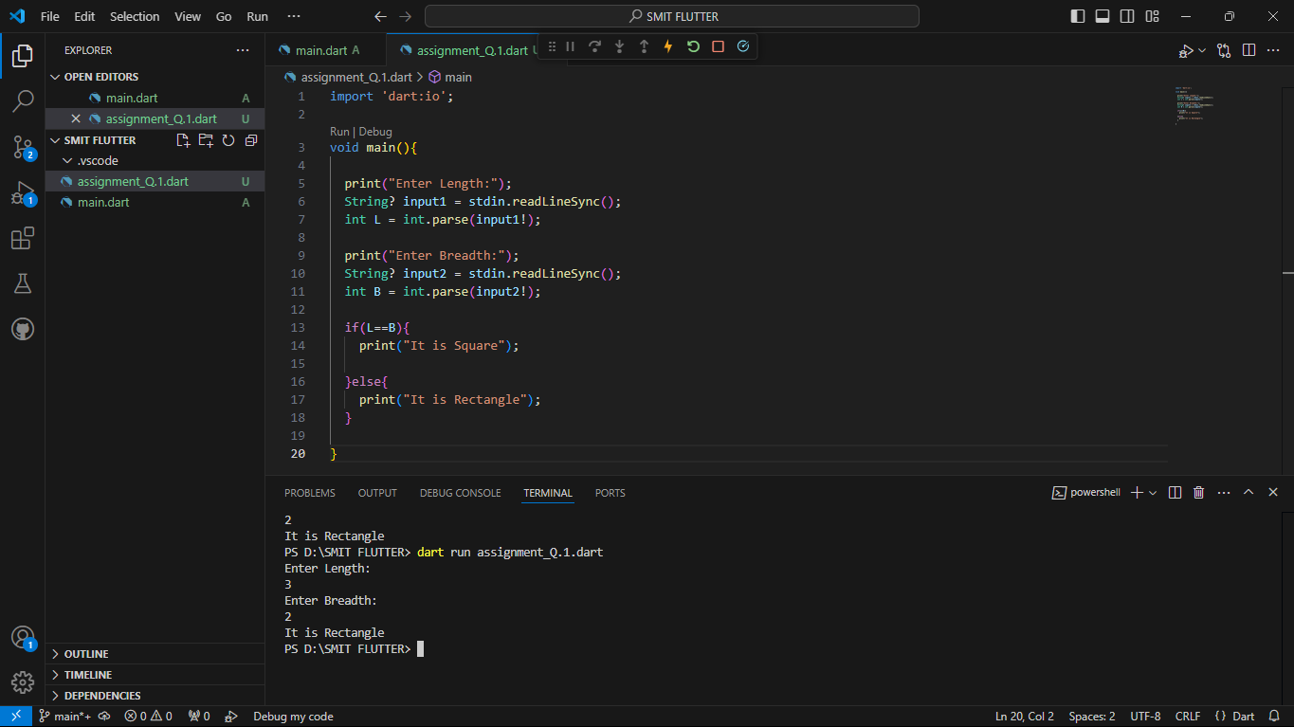

Q.2: Take two variables and store age then using if/else condition to determine oldest and youngest among them.

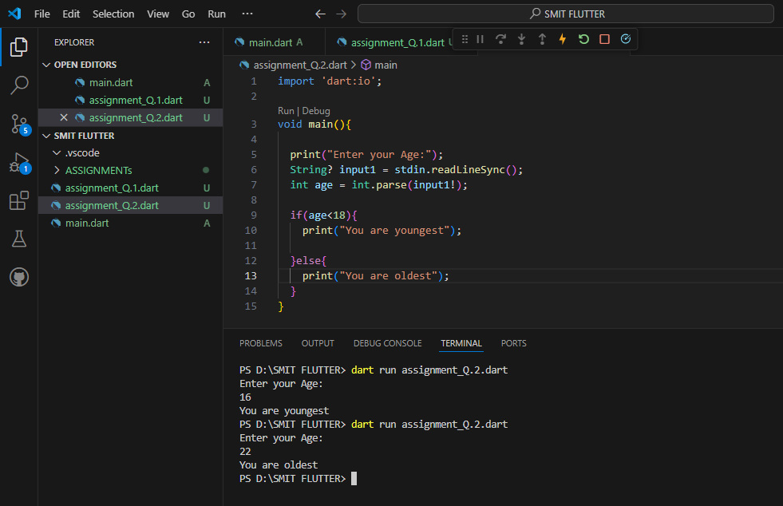

Q.3: A student will not be allowed to sit in exam if his/her attendance is less than 75%. Create integer variables and assign value:

Number of classes held = 16,

Number of classes attended = 10,

and print percentage of class attended.

Is student is allowed to sit in exam or not?

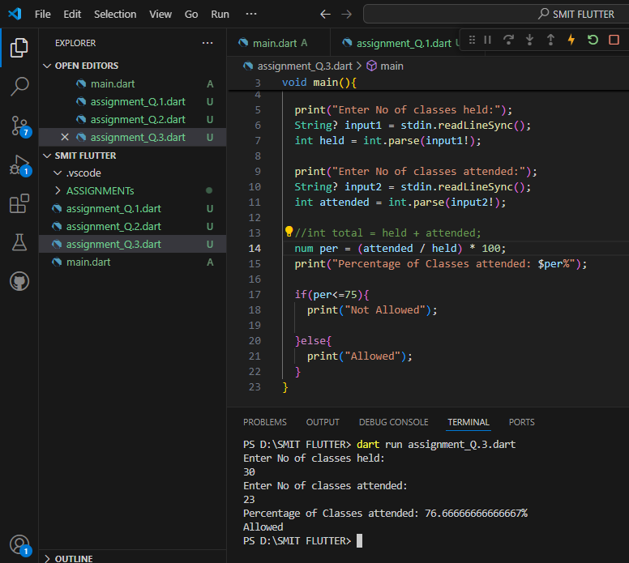

Q4: Write a program to convert Celsius to Fahrenheit .

i.e: Temperature in degrees Fahrenheit (°F) = (Temperature in degrees Celsius (°C) * 9/5) + 32

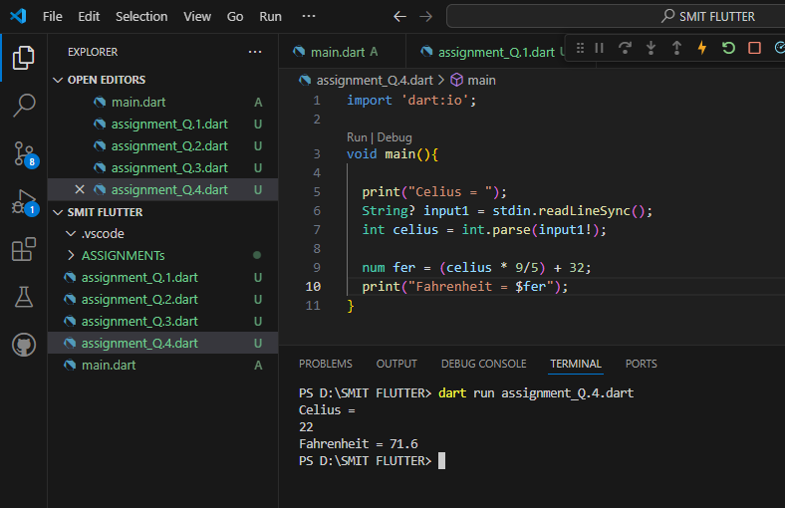

Q.5 Write a program to read temperature in centigrade and display a suitable message according to temperature:

You have num variable temperature = 42;

Now print the message according to temperature:

temp < 0 then Freezing weather

temp 0-10 then Very Cold weather

temp 10-20 then Cold weather

temp 20-30 then Normal in Temp

temp 30-40 then Its Hot

temp >=40 then Its Very Hot

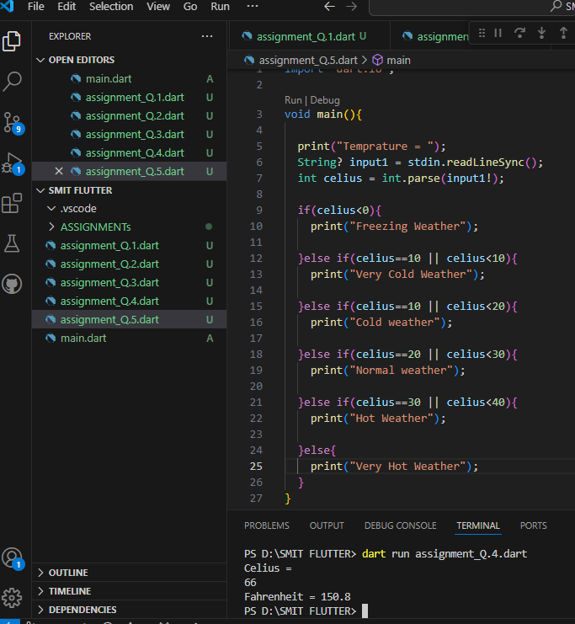

Q.6: Write a program to check whether an alphabet is a vowel or consonant.

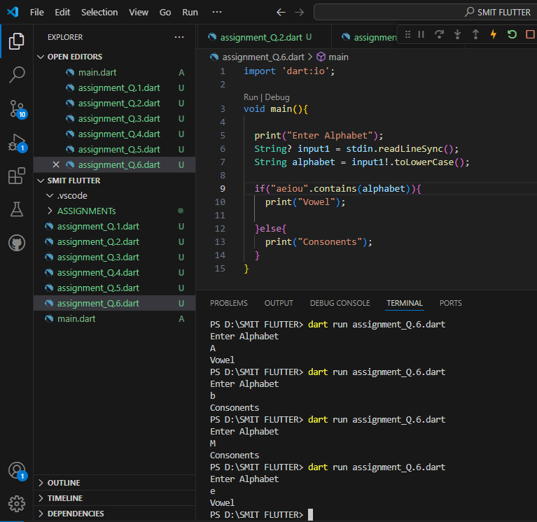

Q7: Create a marksheet using operators of at least 5 subjects and output should have Student Name, Student Roll Number, Class, Percentage, Grade Obtained etc.

i.e: Percentage should be rounded upto 2 decimal places only. 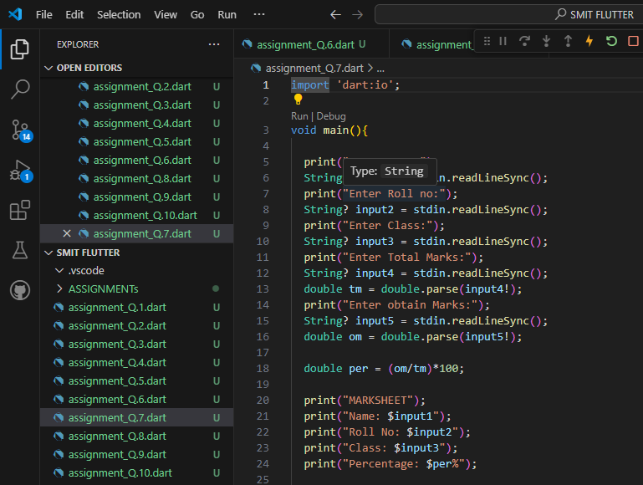

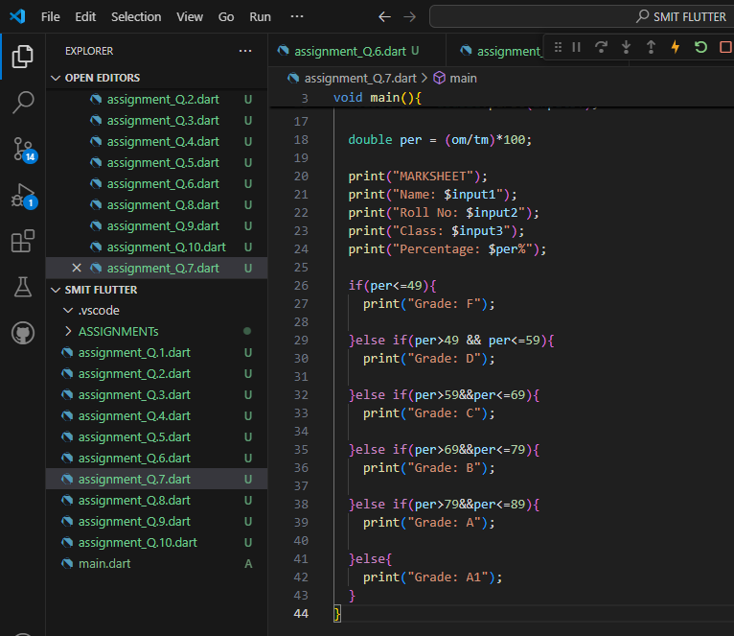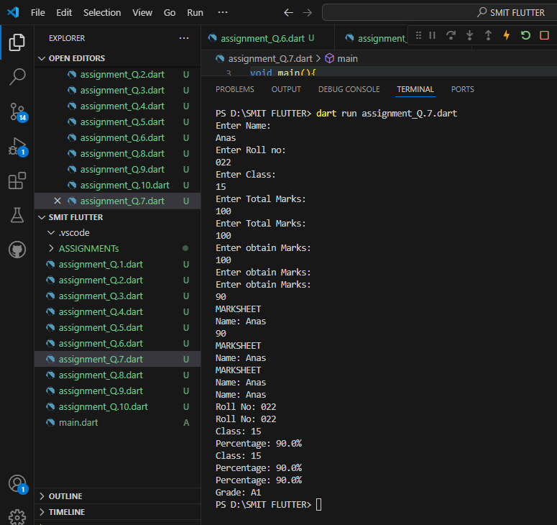

Q8: Check if the number is even or odd?

i.e : Even numbers are completely divisible by 2. (2,4,6,8,10,….)

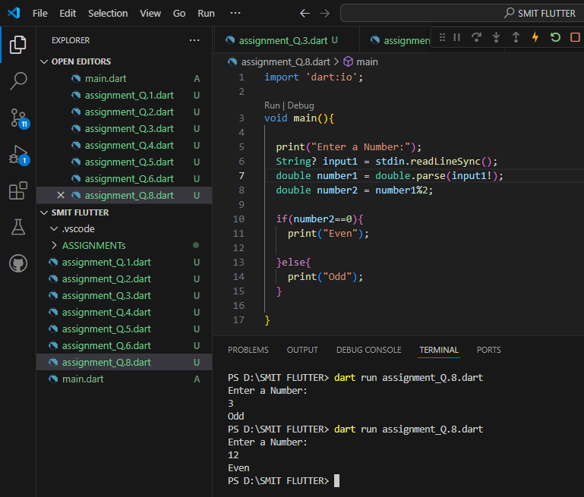

Q9: Check if a number is even then check if its divisible by 5 or not & if a number is odd then check if its divisible by 7 or not.

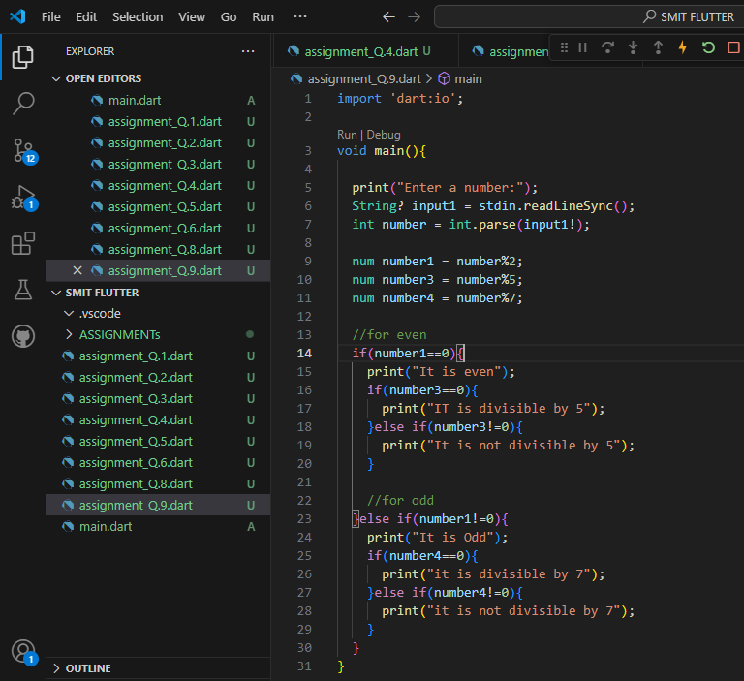

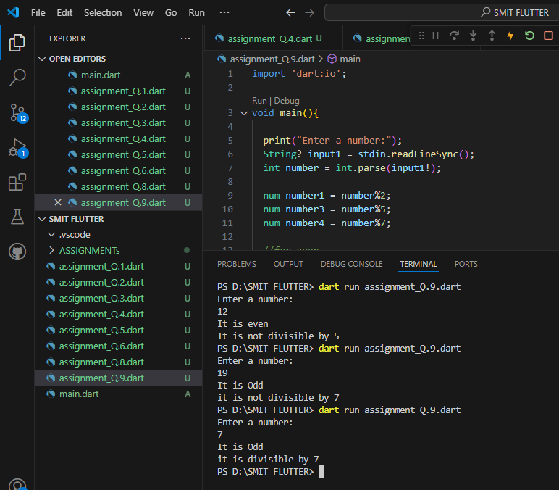

Q10: Write a program that takes three numbers from the user and prints the

greatest number & lowest number. 